**Task 1 : Check all get api that gives proper data or not**

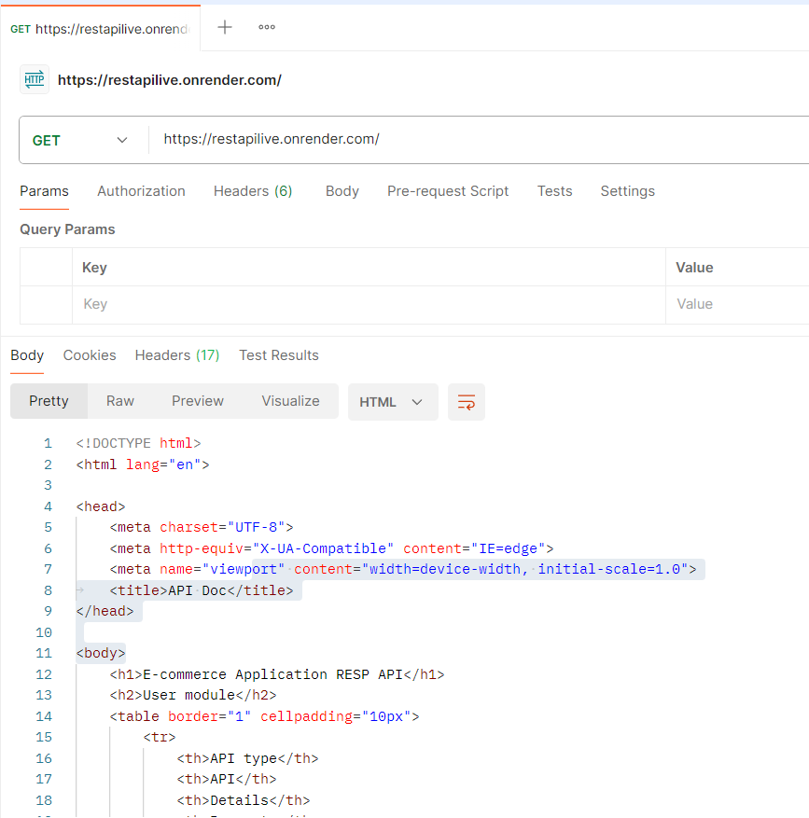

**Task 2 : Verify that POST api ask for authentication or not.**

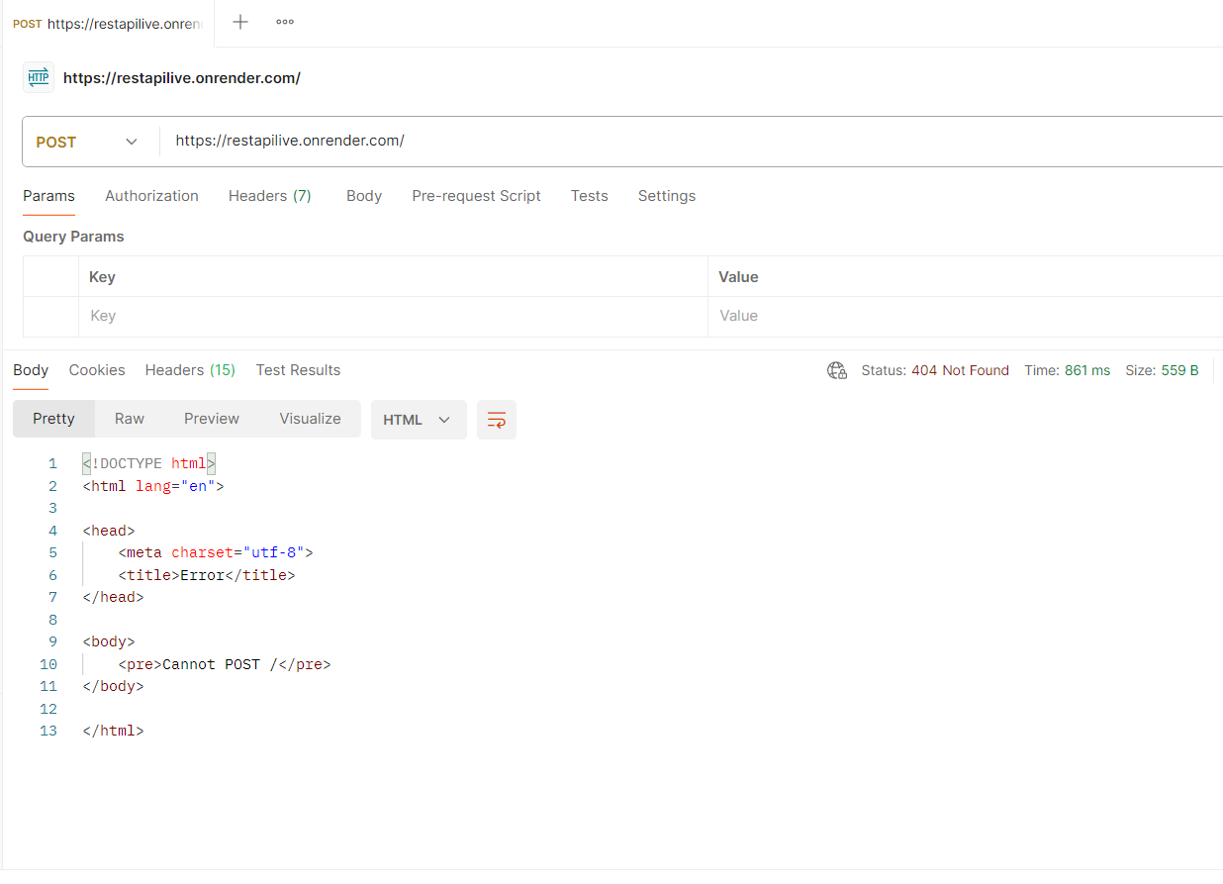

**Task 3 : verify authentication and authorization of API**

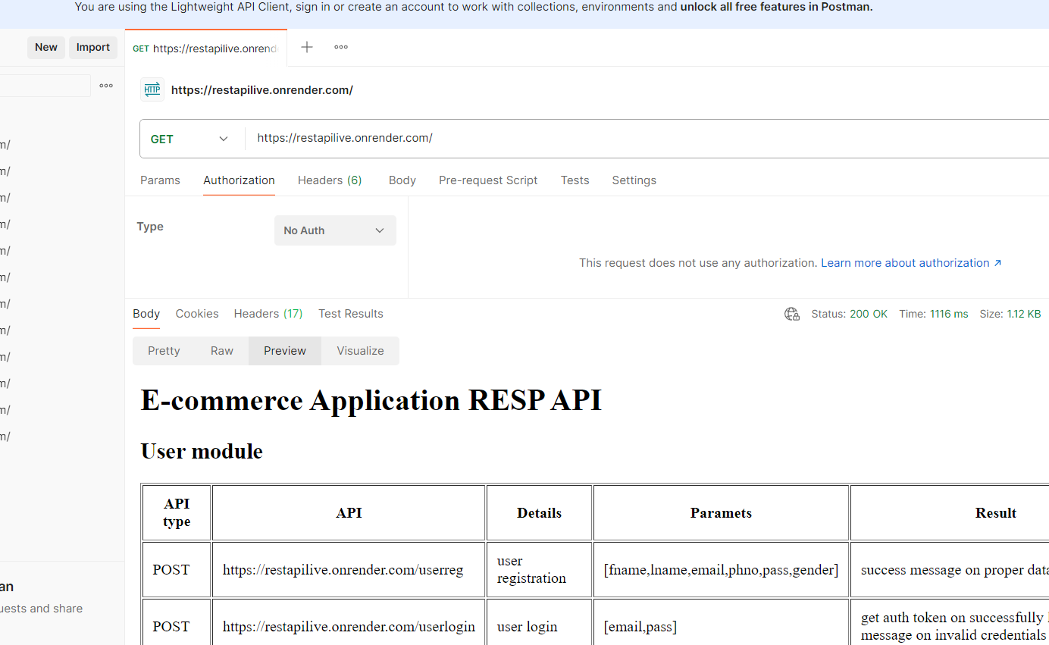

**Task 4 : Check response time of all api**

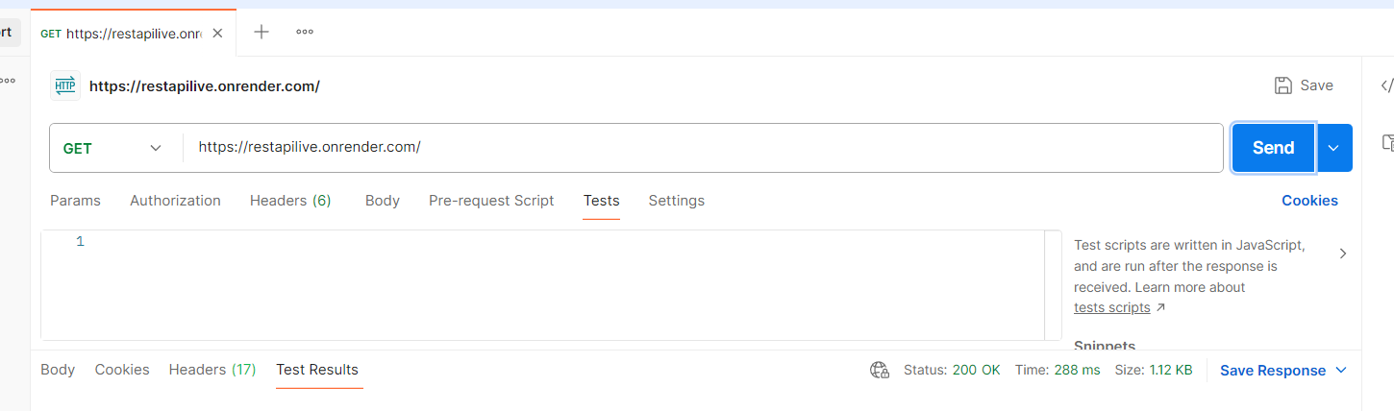

**Task 5 : Add Category data with given parameter**

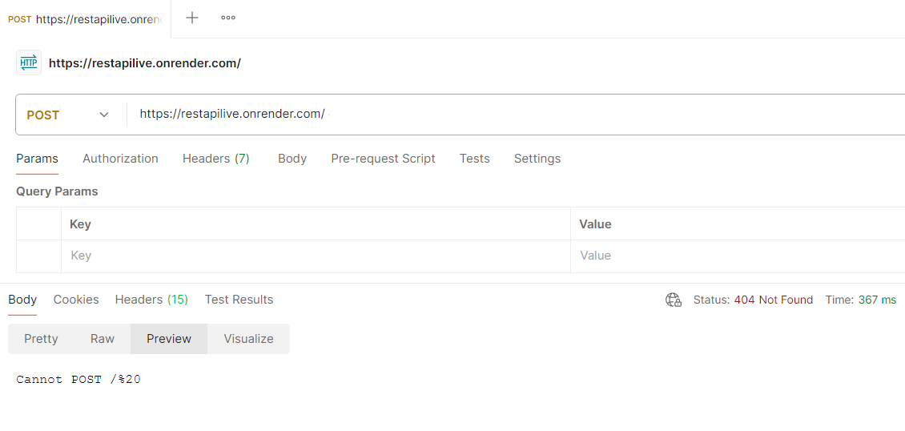

**Task 6: Delete Category Data**

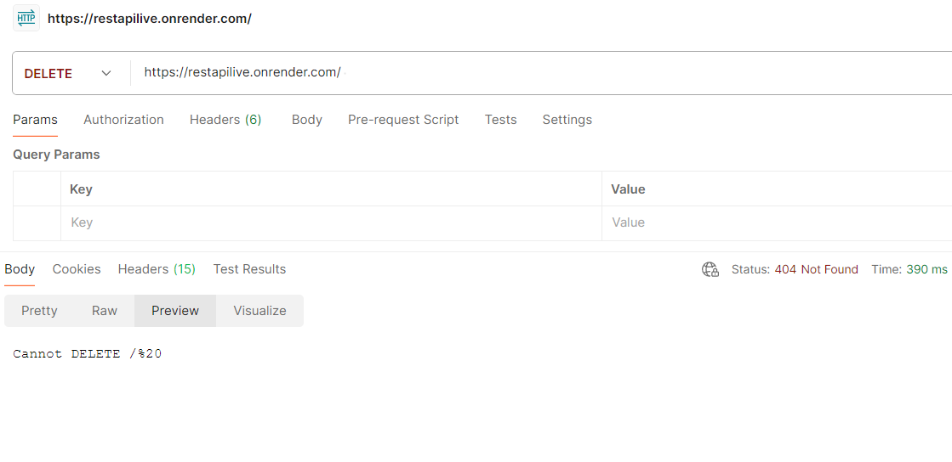

**2) Weather API Testing**

**Task 1 : check to get wheather data with diffent parameter like city wise, lat and lng wise**

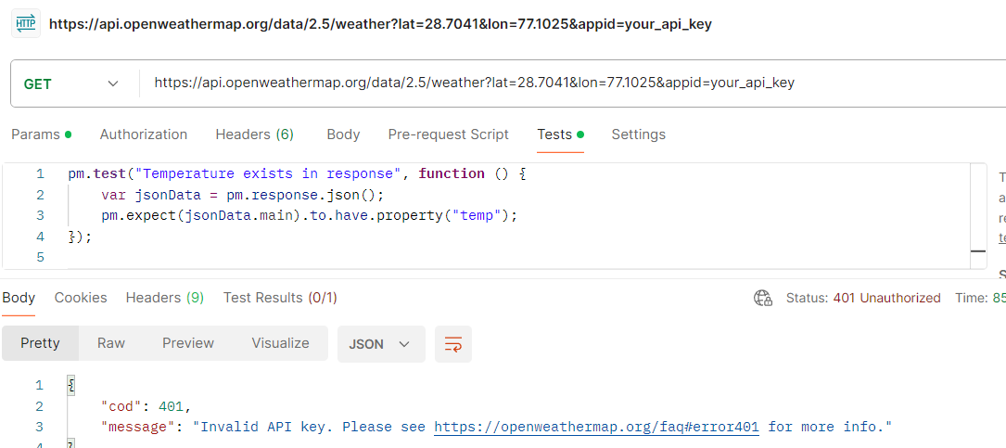

**Task 2 : Check response time of weather data api**

